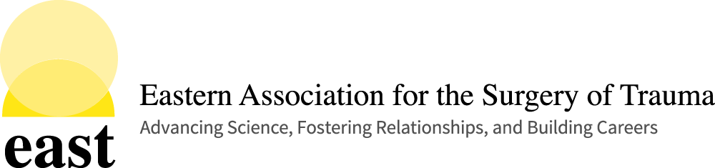

Oral Presentation Discussants
35th EAST Annual Scientific Assembly
January 11-15, 2022 JW Marriott Austin, Austin, Texas

RE: 35th EAST Annual Scientific Assembly

Thank you for agreeing to serve as a discussant for the 35th EAST Annual Scientific Assembly. Below is some information for you as you begin to prepare for your participation at the meeting.

Oral/Podium Presentations: Discussions will be delivered from a podium next to the moderators’ table. Please limit your discussion to two (2) minutes. The discussion time should be used to put the study results into context of existing literature and/or clinical practice, and NOT to re-present the results. The discussion should NOT start with repeating the study data or findings, as these were just presented by the author and does not need to be repeated. Questions for the presenter should be clear and limited to a number that can be handled in a timely fashion (no more than 3-4 questions) and leave time for questions from the floor. The presenter will answer your questions directly after your discussion (not after an additional discussion from the floor). Ideally, this will place the onus on the presenter to actually answer the questions that he/she is asked.

Manuscripts: All Oral/Podium authors have been instructed to submit their manuscripts directly to discussants by December 31, 2021. If you do not receive the manuscript by December 31, 2021, please contact Christine Eme, ceme@east.org, in the EAST Administrative Office.

Publication of Discussion (Oral/Podium Presentations Only) – The Journal of Trauma and Acute Care Surgery (JTACS) has replaced discussion transcripts with a 300-word critique. If the manuscript for the abstract you will be discussing is accepted for publication, as the Primary Discussant, you will be given the opportunity to provide your critique which will be published with the final manuscript.

Registration: All Discussants are expected to register for the meeting and pay appropriate registration fees. Registration information for the 35th Annual Scientific Assembly will be available on the EAST Website. Visit the Annual Scientific Assembly page for program details and registration information. EAST does not offer one day registration.

Meeting/Presentation Attire: The founders of EAST remind us that the scientific meeting is meant to be informal (don’t be more formal than business casual). EAST prefers Hawaiian shirts or casual attire even while you are presenting.

Disclosure: Everyone who is on the program of our assembly (including discussants) is required to complete a disclosure statement, even if you have nothing to disclose. If you are fulfilling multiple roles on the program (e.g. Discussant, Moderator, Presenter), please complete the form taking into consideration your role(s) and disclosure as it pertains to the content of the presentation(s) that you will be giving, moderating, or discussing. Disclosure information will be sent separately. Please complete by the requested deadline. We must have all disclosures on file for CME to be awarded.

Additional Information: Please visit the Information for Presenters, Discussants, and Faculty page on the Annual Scientific Assembly page of the EAST Website, www.east.org for additional information. Please take a moment to review the presentation guidelines document and the disclosure slide template documents that have been posted on this page.

Hopefully this addresses any questions you may have regarding the meeting. Please do not hesitate to contact me through the EAST Administrative Offices at ceme@east.org if you have any questions. Thank you again for participating in the assembly. I look forward to seeing you in Austin, Texas.

Sincerely,
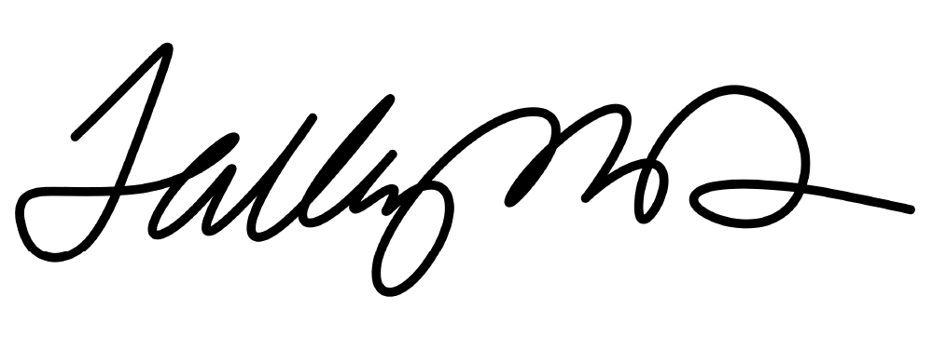
Cynthia Talley, MD, FACS
Director, Division of Education and Chair, Annual Scientific Assembly Committee

Eastern Association for the Surgery of Trauma633 N. Saint Clair Street, Ste. 2400Chicago, IL 60611
Ph: 312.202.5508Fax: 312.202.5064Email: managementoffice@east.orgWeb: www.east.org

