Oral, Quick Shot, & Surgical Video Presenters
35th EAST Annual Scientific Assembly January 11-15, 2022 JW Marriott Austin, Austin, Texas #EAST2022

Dear Colleagues:

We look forward to your presentations at the upcoming 35th EAST Annual Scientific Assembly. Your adherence to the following instructions will help ensure a successful meeting.

Registration: Registration information will be available on the EAST website (www.east.org). Oral, Quick Shot, and Surgical Video presenters are expected to register for the meeting and pay the appropriate registration fees. Please plan to attend the Awards Ceremony on Friday, January 14, 2022 at 12:15 pm; all Alexander and Templeton contestants will be recognized. In addition, the winner of these competitions and the winner of the Best Manuscript award (open to all submitted manuscripts, both oral and quick shot) will be announced.

Manuscript Submission Requirements – DEADLINE DECEMBER 1, 2021

All Oral-Podium, Oral-Quick Shot, and Oral-Video presenters are required to submit a manuscript (and accompanying video for the video presentations). Please review EAST’s Manuscript Submission Rules and Requirements. Failure to submit a manuscript to the Journal of Trauma and Acute Care Surgery (JTACS) will result in future sanctions imposed on the presenting and senior authors.

- EAST Manuscript and Literature Review Committee Pre-Review – The EAST Manuscript and Literature Review Committee will pre-review manuscripts to expedite review to JTACS and to select the Best Manuscript award recipient. While all manuscripts will be considered for publication, there is no guarantee that a paper accepted for oral or quick shot presentation will be accepted for publication in JTACS. Manuscripts must be submitted to JTACS using JTACS’ online Editorial Manager system by December 1, 2021 (see below). Failure to submit a manuscript by December 1, 2021 will result in a one-year sanction for presenting and seniors authors, and any future submission of a manuscript related to that presentation will not be considered with the other EAST papers. See EAST’s Manuscript Submission Rules and Requirements.

- Visual Abstract Submission Requirement – For social medial marketing purposes, Oral & Quick Shot Presenters should submit a visual abstract to EAST that complements the abstract being presented. See “Visual Abstract Instructions” (last page) for details. Visual abstracts must be submitted to EAST (ceme@east.org), by December 1, 2021.

- Surgical Videos – If you are presenting a Surgical Video, the deadline to submit your manuscript and associated video is December 1, 2021. You are required to submit a manuscript and associated video, and BOTH of these items must be submitted by the December 1st deadline. You will receive more detailed instructions about manuscript format and video submission separately.

- Manuscript Submission for Discussant Review – Oral-Podium presenters are responsible for sending a manuscript copy to the assigned discussant in advance of the meeting. EAST will send Oral-Podium Corresponding and Presenting Authors an email with discussant contact information. It will be your responsibility to forward the manuscript to the discussant. Failure to send your manuscript to the discussant by the deadline may result in future meeting sanctions. A manuscript submitted to JTACS will not be automatically forwarded to the discussant; you must send the manuscript to the discussant.
- Journal of Trauma and Acute Care Surgery Manuscript Submission (required for oral, video, and quick shot presenters) – Upload your manuscript to the Journal of Trauma and Acute Care Surgery (JTACS) website, www.editorialmanager.com/jt/
  - Designate your submission as “2022 EAST Podium Paper”, “2022 EAST Quick Shot Paper”, or “2022 EAST Video Paper” in the category area.
  - Please visit the Information for Presenters page on the EAST website for additional information on JTACS manuscript submission guidelines. Questions regarding this process can be directed to David Morris, MD, Chair of the EAST Manuscript and Literature Review Committee via the EAST Administrative Offices at ceme@east.org. Submission Deadline is December 1, 2021.
  - Review EAST’s Manuscript Submission Rules and Requirements. Failure to submit a manuscript to the Journal of Trauma and Acute Care Surgery (JTACS) will result in a one-year sanction imposed on the presenting and senior authors.

Page Two

Oral/Podium Presentation

- Please bring your slides on a Thumb Drive. We will be standardizing slide file naming. Additional information on how you should name your slide file will be sent by email. You will be required to name your file using EAST’s standardized file naming to ensure it is accurately uploaded by the AV staff.
- Personal computers will not be allowed on the podium.
- You are required to include a disclosure slide to be shown at the start of your presentation. See sample disclosure slide on the Information for Presenters page on the EAST website.
- Your presentation must be provided to our AV associate no less than one hour prior to your scheduled presentation time. Please note your presentation cannot be accepted by our AV associate while a session is in progress.
- Oral presentations are limited to 10 minutes.
  - The presentation will be cut short by the session moderators if it exceeds that limit.
  - Invited discussants will then make their comments from a separate podium.
  - You will then be given a brief opportunity to respond to the invited discussant’s questions and comments, prior to the comments and questions being accepted from the floor.
  - The total presentation/discussion is limited to 15 minutes per paper.
  - The presentation will be cut short by the session moderator if you exceed the time limits.
- Review the AV Presenter Guidelines posted on the Information for Presenters page on the Scientific Assembly page of the EAST website.

Quick Shot Presentation

- Please bring your slides Thumb Drive. We will be standardizing slide file naming. Additional information on how you should name your slide file will be sent by email. You will be required to name your file using EAST’s standardized file naming to ensure it is accurately uploaded by the AV staff.
- Personal computers will not be allowed on the podium.
- You are required to include a disclosure slide to be shown at the start of your presentation. See sample disclosure slide on the Information for Presenters page on the EAST website.
- Quick Shot presenters are limited to five slides (title slide included) per presentation. The disclosure slide does not count as one of the five slides.
- Your presentation must be provided to our AV associate no less than one hour prior to your scheduled presentation time. Please note your presentation cannot be accepted by our AV associate while a session is in progress.
- Quick Shot Presentation Time Limits
  - Each presenter will have three (3) minutes to speak to give a brief background of the topic. Presenters are limited to five slides (in addition to the disclosure slide – required)
  - One (1) minute for moderated discussion from questions posted. Discussants have not been assigned for Quick Shot Presentations.
  - Presenter will have two (2) minutes to respond to moderated questions.
  - Total time allowed per Quick Shot is six (6) minutes (inclusive of presentation and discussion)
- Review the AV Presenter Guidelines posted on the Information for Presenters page on the Scientific Assembly page of the EAST website.

Meeting/Presentation Attire: The founders of EAST remind us that the scientific meeting is meant to be informal (don’t be more formal than business casual). EAST prefers Hawaiian shirts or casual attire even while you are presenting.

Hopefully this addresses any questions you may have regarding your presentation. Please do not hesitate to contact me at ceme@east.org if you have any further issues. I look forward to the presentation of your important work during the 35th EAST Annual Scientific Assembly.

Sincerely,
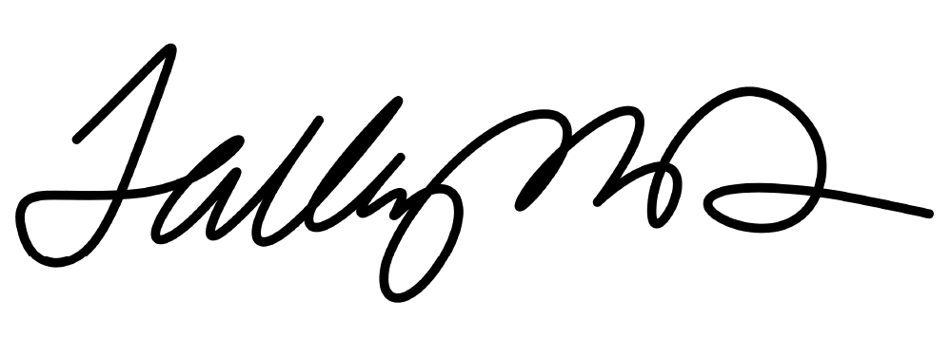
Cynthia Talley, MD, FACS
Director, Division of Education and Chair, Annual Scientific Assembly Committee

EAST Annual Scientific Assembly
Visual Abstract Instructions

What is a Visual Abstract?
The “Visual Abstract” is a graphic summary of key points from the manuscript to help disseminate the science from your article. It is easy to share via social media. Early studies on use of the #VisualAbstract on social media suggests that use of this tool to disseminate an article can lead to increased article views and increased citations. The Visual Abstract is NOT a substitute for the full manuscript.

Resources:
The best resources are from Andrew Ibrahim, who developed the format for the Annals of Surgery. These include:
- Visual Abstract Open Source Primer, available at http://surgeryredesign.com
- YouTube video at https://www.youtube.com/watch?v=CzSvC6ZtS1I

Tips:
- Read the above Primer to become familiar with general format/principles
- Think about your message
- Sketch out several layouts on paper before moving to PowerPoint
  - Layouts based on study design are presented in the Primer referenced above
- Minimize words on the slide
- Minimize colors on the slide
- Use arrows to denote processes or time
- If possible, use simple icons or graphics that can clearly illustrate principles. Possible places to obtain these include The Noun Project or Flaticon. DO NOT use graphics without copyright permission.

EAST Annual Scientific Assembly Instructions:
Use the template provided to allow uniformity. Several layouts and information about suggested color schemes are provided for your convenience.

Submit 2 slides:
1) Table of information for authors 2) Visual Abstract
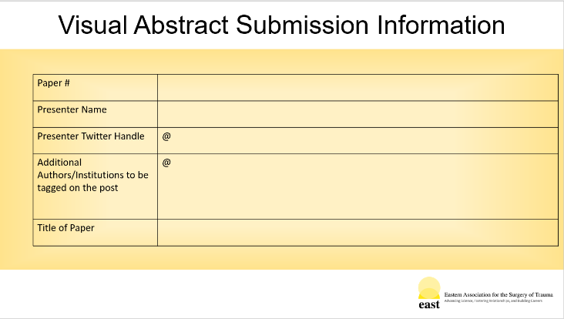
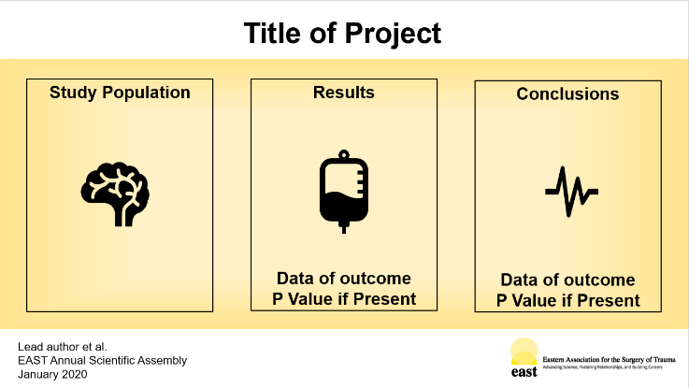
- Submit your visual abstract to EAST using the EAST visual abstract template to ceme@east.org. The Submission deadline is December 1, 2021.
- Abstracts will be reviewed by the Visual Abstracts Task Force of the Annual Scientific Assembly Committee and you will receive feedback and requests for revision
- Final revised abstracts must be resubmitted by January 1, 2022 and emailed to Christine Eme at ceme@east.org by January 1, 2022.

